# Crowdfunding Campaigns Analysis Report

Based on the data provided, we can conclude that:

1. The most popular campaigns are created for theater, 34%, followed by film and video ,17.8%, and Music ,17.5%.
2. The campaigns’ success rate slightly higher in Jun and July. The success rate reaches to 63.95% in Jun which is the highest rate and 62.37% in July comparing to 57.30% all year around average.
3. Although the goal of the campaigns and success rate varies, the most successful campaigns fall between 15000 to 49999. The trendline shows that the campaigns that aim to receive less than 1000 and more than 50000 have higher failure rate, 39% and 53% respectively.

However, the data has its limitations. We do not have any information about how many people worked on the campaigns, how much money and time spend on advertising the funding page in other platforms. We also don’t have any information about the target audience of the campaigns. Similarly, no information about “backer’s” such as age, gender, income level.

## Additional Analysis

Following charts can be added to the analysis:

1. Country analysis by number of campaigns and success rate can be done to see whether any geographic, cultural differences effect the data. Although US leads in the number of campaigns 43.6%, CH campaigns are most successful with the 66.67 % success rate
2. Yearly trend analysis can be added to see whether crowdfunding experience is a factor. The data shows upward success rate year over year.
3. We can add whether duration of campaign has any effect on the success of campaigns. This concludes that duration has no significant effect on the outcome as failed campaigns had average of 16 days whereas successful campaign had average of 15 days length.
4. We can also add success rate of parent categories. The analysis will present that the most popular campaigns category “theater” is not the most successful. The most successful category is photography followed by “Technology”.

## Statistical Analysis

The statistical analysis of successful and unsuccessful campaigns based on their backers’ count shows that median is a better representative of the data. Both data set have outliers that increases the Mean of the data. Most of the data is clustered around Median in both data set. Although Median of 851 backers should better represent the data as the campaign success rate is positively corelated with the number of backers. However, in this data set the number of successful campaigns that have the goal of up to $10K makes 59% (385/565) of the data set (successful campaigns) and the average number of backers for these campaigns is 157. Therefore, Median better represents the the data.

For Successful Campaigns the statistical results are below:

|  |  |  |  |  |
| --- | --- | --- | --- | --- |
| Successful Campaigns | | | | |
| Mean | 851 |  | 1st Quartile | 128 |
| Min | 16 |  | 2nd Quartile | 201 |
| Max | 7295 |  | 3rd Quartile | 1289 |
| Variance | 1606217 |  | Interquartile | 1161 |
| Standard Dev | 1267 |  | Lower Boundary | -1614 |
| Median | 201 |  | Upper Boundary | 3030 |
| Mode | 80 |  |  |  |

Plot Box-A

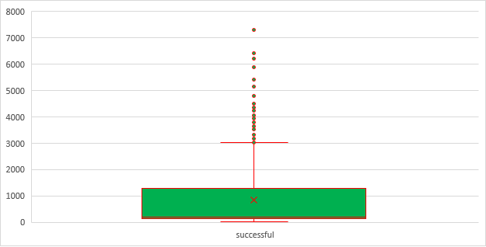

2nd quartile (Median) is closer to lower 1st quartile 50% of the successful campaigns have 16 to 201 backers. The rest of them spread out widely. 3000 and upper levels represent outliers.

Similarly, most of the data is clustered around Median for the Failed campaigns as well. There is a negative correlation between number of backers and failure rate as the number of backers decreases, the failure rate increases. There is also higher failure rate for the campaigns that have higher goals. Below is the data for the Failed campaigns

|  |  |  |  |  |
| --- | --- | --- | --- | --- |
| Failed Campaigns | | | | |
| Mean | 586 |  | 1st Quartile | 38 |
| Min | 0 |  | 2nd Quartile | 115 |
| Max | 6080 |  | 3rd Quartile | 790 |
| Variance | 924113 |  | Interquartile | 752 |
| Standard Dev | 961 |  | Lower Boundary | -1089 |
| Median | 115 |  | Upper Boundary | 1917 |
| Mode | 1 |  |  |  |

Plot Box B

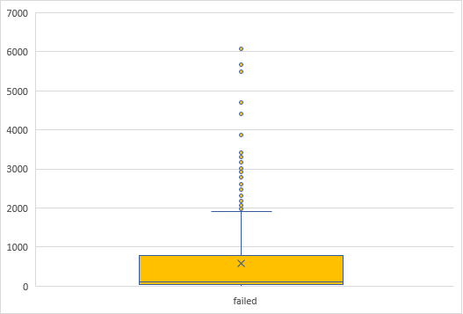

Although variability of the data is similar, the successful campaigns spread wider range than the failed campaigns. Also, standard deviation is higher for the successful campaign which indicates higher variability.